**Khyber Pakhtunkhwa:**

Kumrat Valley

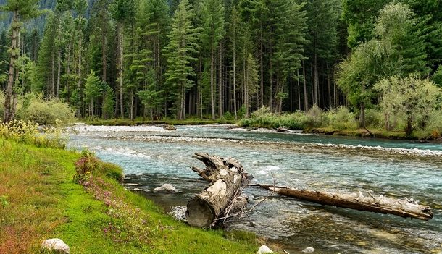

**Kumrat** is a valley in the Upper Dir District of Khyber Pakhtunkhwa the Province of Pakistan. It is one of the scenic valleys of Khyber Pakhtunkhwa and a picturesque spot for travelers. Every summer season thousands of tourists from different areas of the country visit to Kumrat valley and enjoy the greenery and cool weather.Kumrat is covered with green pastures, snow clad mountains, the river Panjkora, foggy mounds and forests are attractions of the region, which serve as habitats for variety of flora and fauna.It is located in the Upper Dir Kohistan region at the back side of which Swat Kohistan area of Gabral is located.